**Practical – 10**

**Aim: -** Connectivity Troubleshooting using PING, IPCONFIG, IFCONFIG

**Network troubleshooting: -** It is a repeatable process which means we can break it down into steps:

1. Identify the problem.
2. Establish a theory of probably possible causes.
3. Test the theory to determine the causes.
4. Establish a plan of action and implement the solution.
5. Verify full system functionality and implement prevented measures.

**IP configuration :-** It display all current TCPIP network configuration values and refresh the dynamic host configuration protocol and domain name system settings .it gives you basic information to get your IP address your routers IP address DNS server IP address and DHCP server IP address.

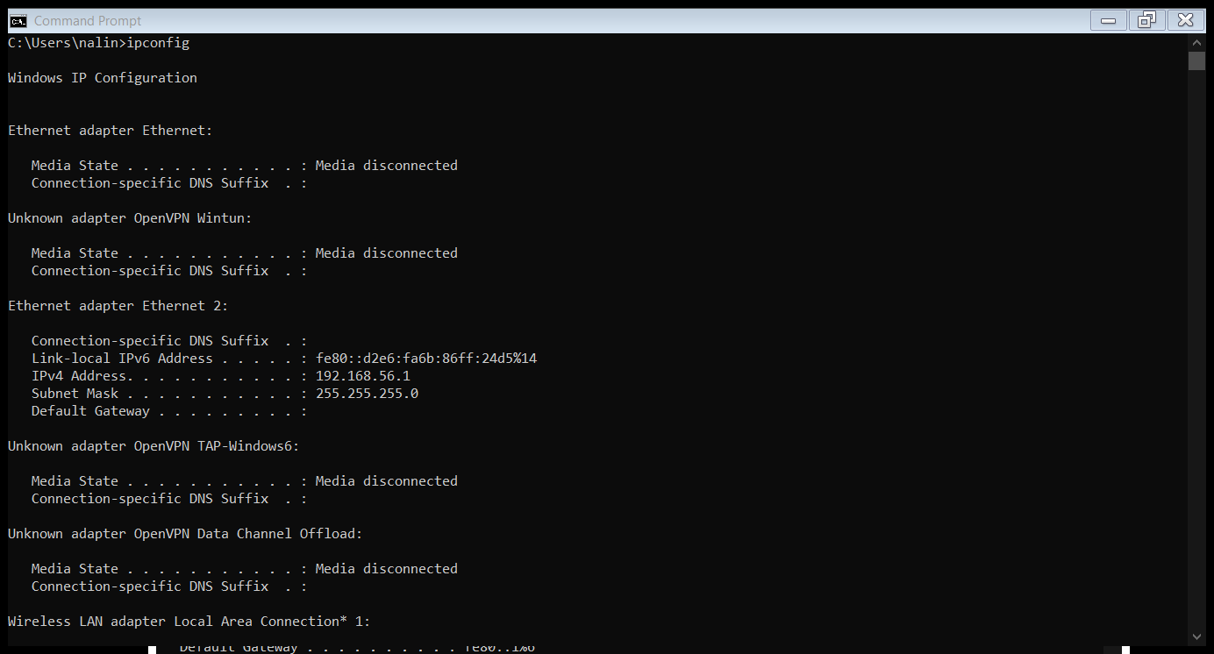

**IPCONFIG /all: -** It also gives information about DHCP server when we will type *ipconfig /all* and press enter there is a space between the command IP configuration and the switch of /all. It retrieves all TCIP network information (MAC address, adapter description, DHCP details).

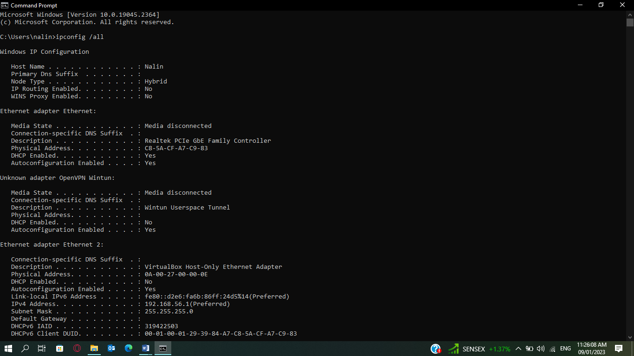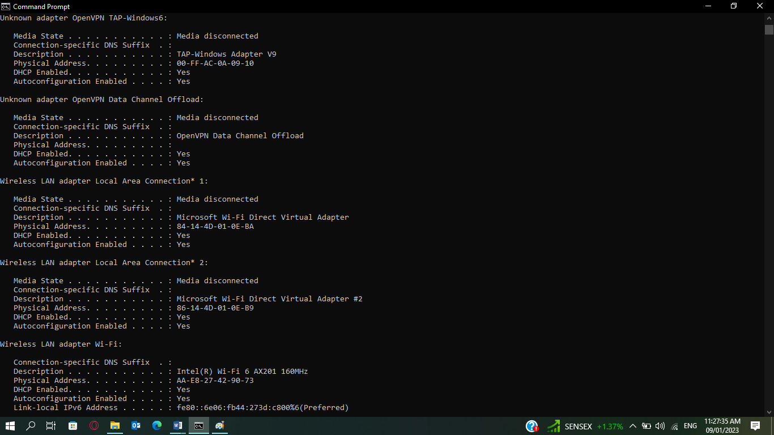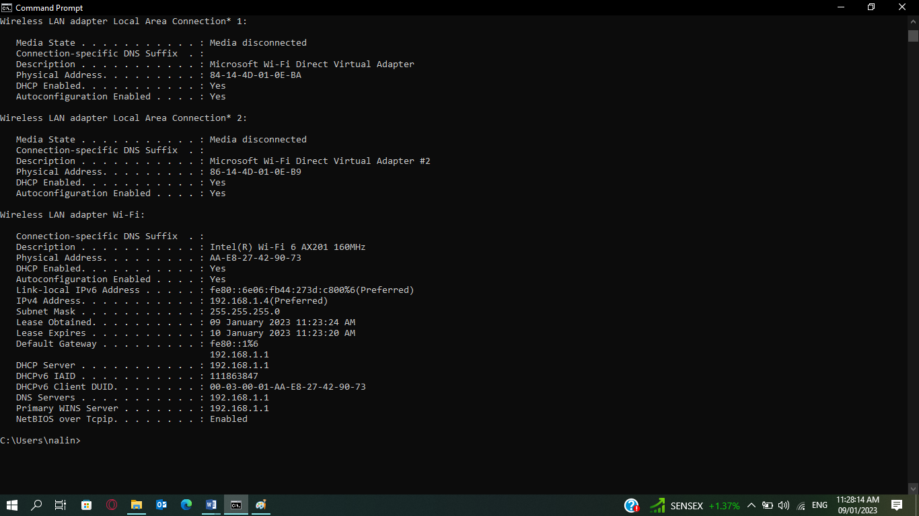

**PING command: -** It allow to send a signal to another device on the network to see if it is active or not. It uses the ICMP internet control message protocol to send out and echo request to the destination device and get back an echo response if the device you are trying to reach of in fact active.

**Ping 198.168.1.1:-** This IP address is used as default router IP address on private networks. It can also be used by other devices connected to private network by Linksys router. If router is down and we are trying to ping it and we are not getting the response it means connection is not stable.

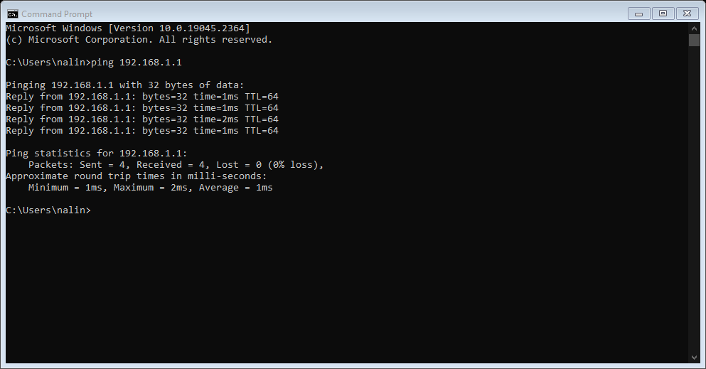

**Ping** [**www.google.co.in**](http://www.google.co.in)

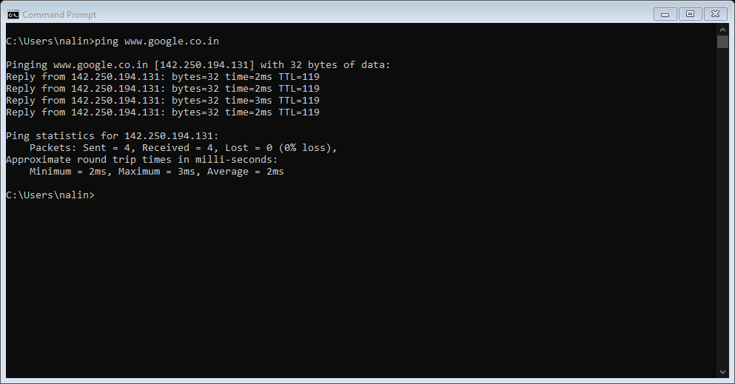

**IFCONFIG: -** It is a system administration utility in UNIX like operating system for network interface configuration. It Display the current network interface configuration information.

The *ifconfig* command must be used at system startup to define the network address of each interface present on a system.

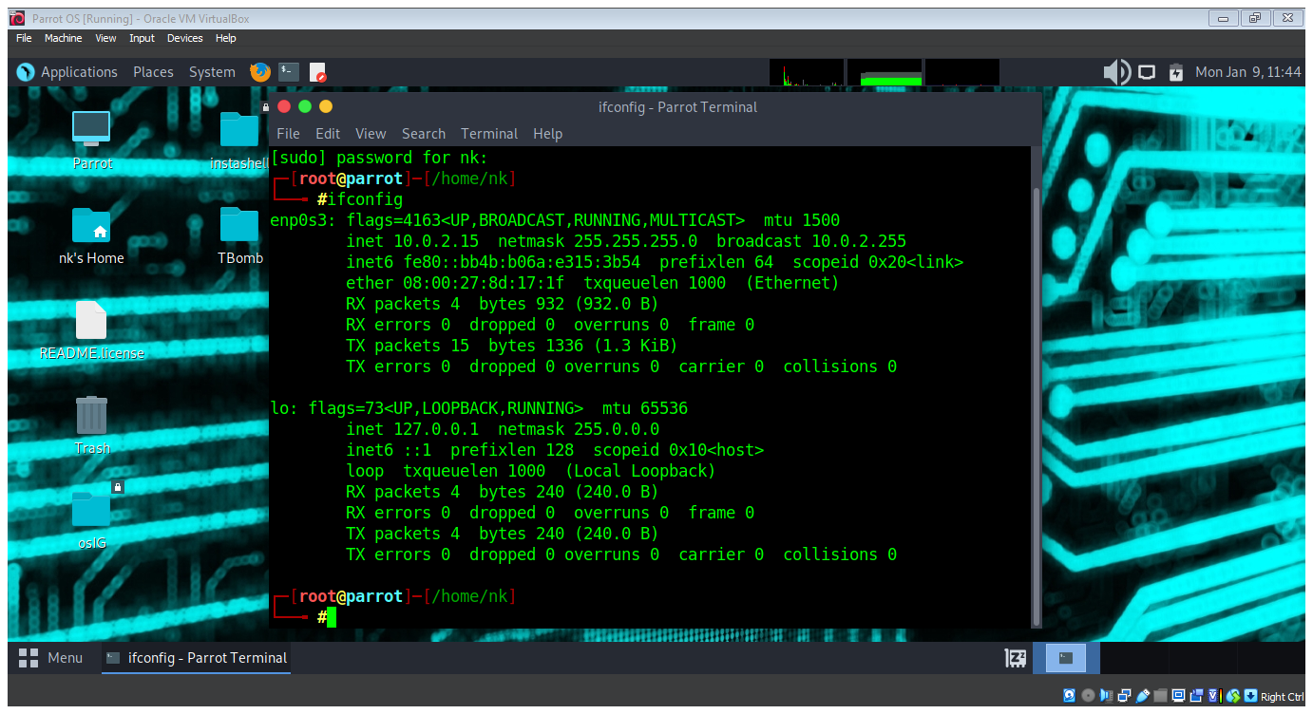

**Functionality :-**

The IP CONFIG command display all the currently connected network interfaces whether they are active or not .

On the other side the IF CONFIG command display only the enable network interfaces that are connected to the system.